Operational Implications of MIPS 160μm Cable Flaw
J. Stansberry, H., Dole, E. Egami, C. Engelbracht, G. H. Rieke
August 16, 2002

1. Introduction

On the morning of October 29, 2001, MIPS was being set up for obtaining baseline 160μm data with the CTA at cold conditions in Brutus. Between two successive data runs, separated by about 15 minutes, the output of readout 3 (five pixels) of the 160μm array quit producing signals within the range of the CE data system. There had been no change in array operations -- power had been on continuously, there had been no temperature excursions, or any other activity that could explain the change. The problem went away when the instrument electronics were warmed and did not reoccur when they were cooled again.

The most likely cause of this problem is a fault in the low-thermal-conductivity cabling between the MIPS Jbox and the cryostat. The portion of this cabling between the Jbox and the CTA base ring was replaced, but the cabling inside the base ring was not because doing so would have required major disassembly of the CTA. The problem was not seen again until the Thermo/Vacuum test at Lockheed. There, when the outer shell went cold, signals were again lost from readout 3, apparently in an identical manner to what had happened in the Brutus testing. The loss of signal prevailed so long as the outer shell remained cold (regardless of the CE temperature), but the signal returned at the end of T/V when the outer shell warmed up.

A technical description of the potential causes of this failure, with more details on the testing and failure analysis, is given elsewhere (Analysis of Loss of Signal from MIPS 160μm Array, Rev. A, G. H. Rieke, August 9, 2002. The behavior does not indicate a hard failure - the problem appears to be associated with the outer shell going cold, but we have seen signals from this readout with the outer shell cold. Therefore, we cannot predict whether the outputs from readout 3 will be available on launch, but in the following we discuss the implications of their being absent.

2. General

The major steps that need to be taken with regard to this possible failure are:
1. Notify all users of SIRTF (GTO and Legacy) of this potential problem
2. Update the SOM (SIRTF Operations Manual) to capture the nature of the problem. This should include illustrations showing coverage implications for all AOTs.
3. Prepare to implement a change to the Small Source Photometry AOT at 160μm as outlined below. This change should be available for use on the observatory no later than the beginning of SV.
4. Modify scan map AOT to allow offsets in cross-scan by 10(TBR) pixels
5. Develop a strategy for dealing with reformulation of programs that utilize the 160μm Photometry AOT.

Further details of the recommended actions for bullets 3, 4, and then 1 are given below.

3. Small Source Photometry

The AOT for small source photometry should be changed to use 7 DCEs per cycle, plus one additional DCE for calibration. We understand how to adjust the scan mirror commanding to do this, and are confident that data from this AOT will provide undiminished performance relative to the current AOT with all readouts. The frame table should also be changed to give a nod of 5 cross-scan by 0 in-scan pixels. The nominal positioning of a source on the array also needs to be adjusted.
The recommended pattern of integrations on a source is shown in Figure 1. The diameter of the circles is about that of the first dark ring of the diffraction pattern, and roughly shows the size of a source measured down to sky. The numbers indicate the level of redundancy in the coverage with a single set of measurements, and the grey-scale gives the same information. The two top panels show the results from two sets of 7+1 DCEs with an intervening spacecraft wobble. The bottom panel shows the resulting mosaic on the sky, showing that the pattern achieves good coverage on the source while also measuring the surrounding sky well.
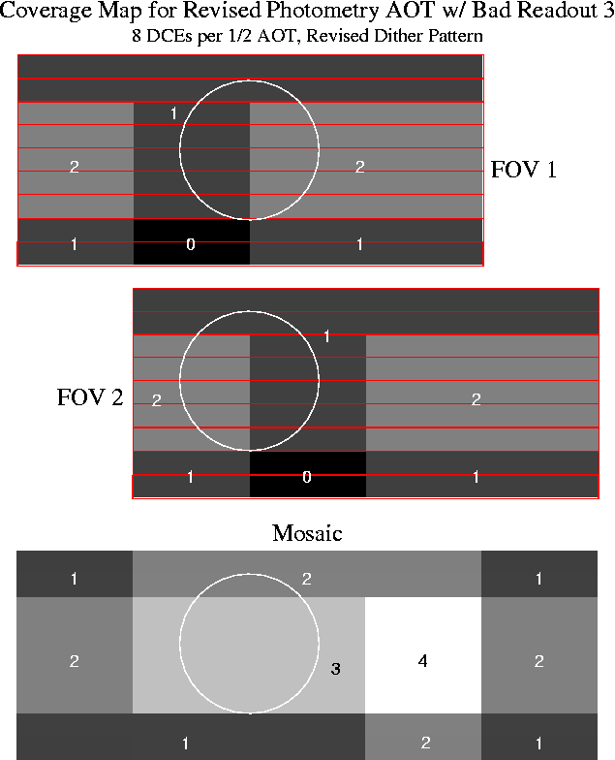

Figure 1. Recommended pattern of integrations.

Because of the gradient in stimulator brightness across the 160mm array, there is a gradient in the accuracy of flat fielding and thus in achieved sensitivity. Figure 2 is similar to Figure 1 but it shows the achieved sensitivity in a grey-scale presentation. It can be seen that the recommended pattern not only provides good redundancy in the data (Figure 1), but it also places the source near the region of maximum sensitivity.

4. Large Source Photometry

For large source photometry, the largest changes are basically in the instructions to observers. They need to be urged strongly (or required) to do not only 4 cycles of the AOT, but also to use the following dither pattern in units of pixels:

Cycle | X-scan | In-scan
1 | 0 | 0
2 | 5 | 0
3 | 5 | 2
4 | 0 | 2

In addition, the frame table should be adjusted so the source tends to fall toward the upper portion of the mosaic away from the affected readout.

Figure 3 shows the number of repetitions in this pattern, similar to Figure 1. Figure 4 shows the signal to noise. Because this pattern will be used on extended sources, the pattern of signal to noise over the entire mosaic area is of interest, and so we also show it graphically in Figure 5.
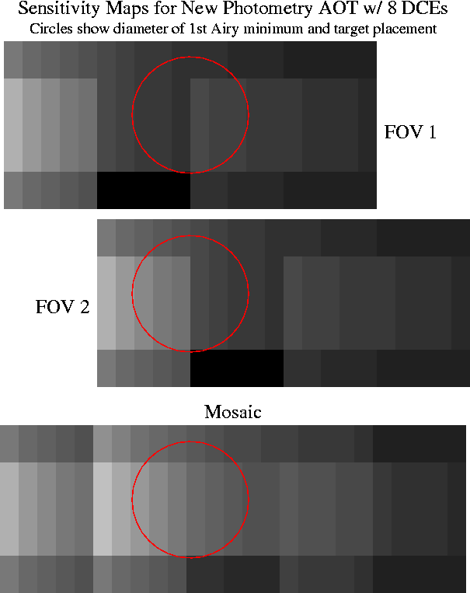

Figure 2. Signal to noise for the recommended small source photometry pattern.

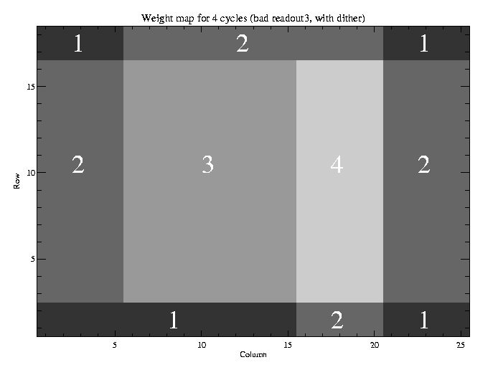
Figure 3. Weights (number of repetitions) for the recommended pattern in large source photometry.
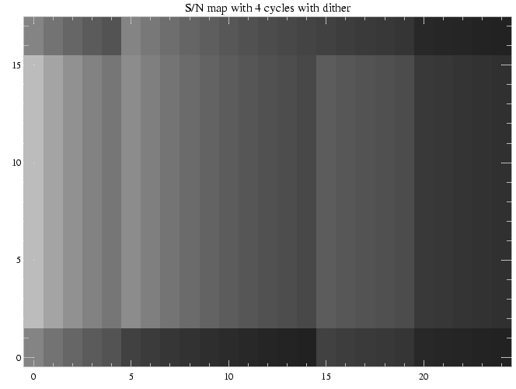

Figure 4. Signal to noise map using the recommended strategy.
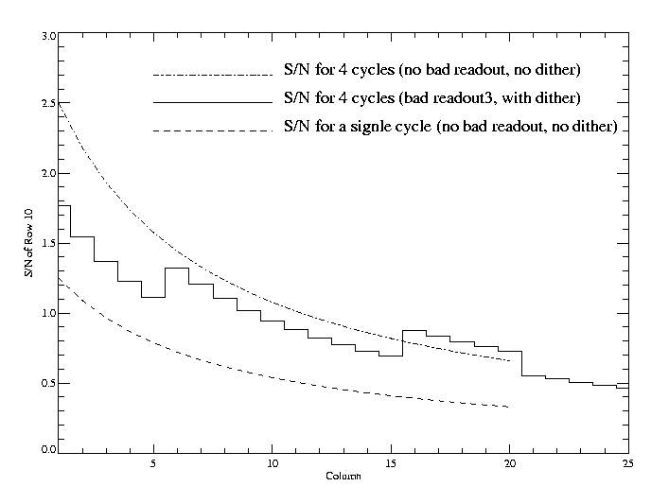
Figure 5. Relative signal to noise across the array using recommended large source photometry strategy. The solid line shows the effect of moving the spacecraft by 5 pixels between sets of integrations.

5. Scan Map

In scan map observations with many passes, the impact of losing readout 3 is to decrease the net integration time in proportion to its relative area on the sky, i.e., to 7/8 of the nominal value, so long as appropriate dithers are used to provide uniform coverage. Thus, the major change required is to update the SOM to urge observers very strongly to use 1/2 (TBR) array offsets if they want good 160μm data. The exact size of the optimum offset is still under evaluation.

Where only a few repetitions are planned, the lack of redundant 160μm coverage may be more serious. The simple solution is to carry out at least three repetitions, to allow at least two sightings of every area on the sky regardless of the loss of the output of readout 3. Where only two repetitions were planned, this modification is very expensive in time. The alternative is to use interpolation to "fill in" the lost data, but clearly the reliability will suffer. These questions are beyond the issue of operations adjustments.
6. Draft Statement to GTO and Legacy Community

We suggest that a statement such as the following be released to the SIRTF user community:

"During both episodes of SIRTF Thermal Vac testing one block
of 5 contiguous pixels on the MIPS 160 micron array exhibited
anomalous behavior which is attributable to a thermally activated
short in cabling. There is a significant probability that this
part of the 160 micron array will not return useful data once
SIRTF is on orbit. The SSC and MIPS Instrument Team have formulated
a contingency plan to deal with the problem should it exist after
launch. GTO and Legacy observers may be asked to re-submit AORs
using the 160 micron array, and there will probably be an increase
in the time required to observe any particular target at 160 microns.
The call for this resubmission, should it be needed, will occur
in roughly mid-IOC in order to support the start of regular science
operations at the end of IOC/SV."

