MIPS 70 Micron Array Readout (Channel 2) Anomaly

ISA Z81711

Erick Young, George Rieke, Jerry Heim, John Stansberry, Doug Kelly, and Tom Glenn

September 9, 2003

1. Summary

In reviewing the data from MIPS Campaign A1, it was found that one readout of the 70 μm array was at the negative rail. The other readout outputs were at the positive rail due to saturation on the strong signals from the telescope. Therefore, there is an anomaly affecting the readout (number 4,4).

We have reviewed prelaunch test data and found that the readout was operating correctly then. We have also gone back to data independently of the MIPL processing and found that the readout 4,4 data were railed negative there. We therefore conclude that the issue is new and is in the flight hardware.

In Campaign B, we found that readout 4,4 was operating correctly – the anomaly had apparently been corrected. Before this anomaly is fully resolved, we will have to track the behavior of the array for a number of additional campaigns. However, the situation is well enough defined for a report on possible causes.

2. Anomaly Description

A greyscale representation of the output of the 70 μm array as it was throughout Campaign A1 is shown in Figure 1. Figure 2 shows the array output levels. Readout 4,4 is at zero for the duration of the test, and was not seen to deviate from this reading throughout Campaign A1. All the other readouts were saturated positive by the very high background level from the relatively warm telescope, except for readout 4,7. That readout was known prior to launch to have a short on its output to chassis ground through a resistance of approximately 40 kΩ. The resultant loading of the signal puts the saturation level below the nominal rail of the system. The data in Figure 2 indicate that the value of the short has not changed substantially between ground test and the on-orbit data.

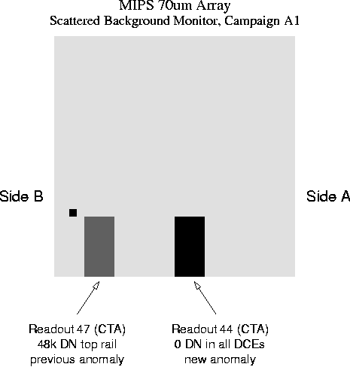

Figure 1. 70μm Array Output. Readout coordinates start in the upper right corner. Readout 4,4 is driven hard to the negative rail. Readout 7,4 has a short to chassis ground similar to that observed previously. There is a bad pixel on readout 8,3.

Figure 2. 70μm Array Outputs. 30 of the outputs were at the A/D limit, indicating full saturation. Readout 4,7 is also indicating saturation, but its output is dragged down by the partial short to CTA chassis ground. It also shows vestigial integration ramps that are off scale for the other readouts. Readout 4,4 (indicated by the arrow) is at zero and remained there throughout the test.

3. Failure Analysis

Figure 3 below shows the overall layout of the MIPS electronics. The cabling between array and warm electronics is shown in Figure 4 (reversed from right to left compared with Figure 1). Failures can arise in: 1.) the array; 2.) the cabling between warm electronics and array; or 3.) the warm electronics. The correct behavior of the remaining readouts in the array, and the restoration of correct behavior on readout 4,4 during Campaign B, both indicate that there is no problem on the digital side of the circuit, nor in the computer program that handles the data.
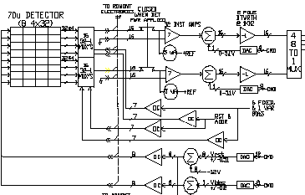
Figure 3. Overall layout of the electronics. The transition from cold to warm is the dashed vertical line. Signals from 4x8 pixel sections of the array are brought to a 32-channel readout and then through the cryostat wiring to the warm electronics. There, they are received by a differential amplifier, pass through an offsetting amplifier and filter, and are delivered to the MUX and A/D.

3.1 Array Failures

The possibilities we have identified for a failure within the array are either that the readout itself has failed, or that a wire bond bringing a power line to the readout or carrying the signal to the output connector has broken (see Figure 5). A careful review of the telemetry indicates no asymmetry between sides A and B of the array in current draw, and no significant differences from ground readings except for those resulting from the very high background. In general, failure of the readout or of a power line would be reflected in a change in current draw. We conclude that a failure within the array other than in the output wirebonds is unlikely.

3.2 Cable Failures

External to the array, the failure could result from a break in the readout wire in the instrument cabling or connector, in the CTA ribbon cabling or connectors, in the spacecraft cabling from the junction box to the electronics, or in the junction box.

In the Combined Electronics box, for each of the 32 readouts of the 70μm FPA there is a 5 micro-amp current source in the warm electronics that is used to bias the source follower output amplifier in the FPA. This current source is also connected to the instrumentation amplifier in the combined electronics. If the connection between the current source and the output amplifier is broken, the current source would go to its positive rail voltage (about +7V). The instrumentation amplifier and the low-pass filter that follows have gains of –7. Thus, if the connection were broken, the output of the low-pass filter would go to the negative rail. With the filter output at the negative rail, the ADC would produce all zeros. This is exactly what we are seeing.

A review of the positions of the wires involved indicates none of them are at the end of a connector, making it unlikely that the failure arises through a partially seated connector. Nonetheless, a workmanship issue in attaching to a connector pin or something similar remains a possibility. Issues of this latter type have already been discovered in the cryogenic ribbon cables, during ground testing.

Figure 4. Cabling diagram between detectors and warm electronics.

3.3 Warm Electronics Failures

Figure 6 shows the receiver differential amplifiers in the warm electronics boxes. The decoupling relays allow the signals to be isolated to the box in use. Just as with an open signal cable, the differential amplifier would drive to the rail if the decoupling relay or electronics box connectors have failed open. In addition, there could be a failure in the differential amplifier itself. We could also end up at the rail with failures in any of the analog chain components downstream of it, up to the multiplexer. Finally, there are possible generic electronics failures such as in the motherboard in the electronics, in solder joints, etc.

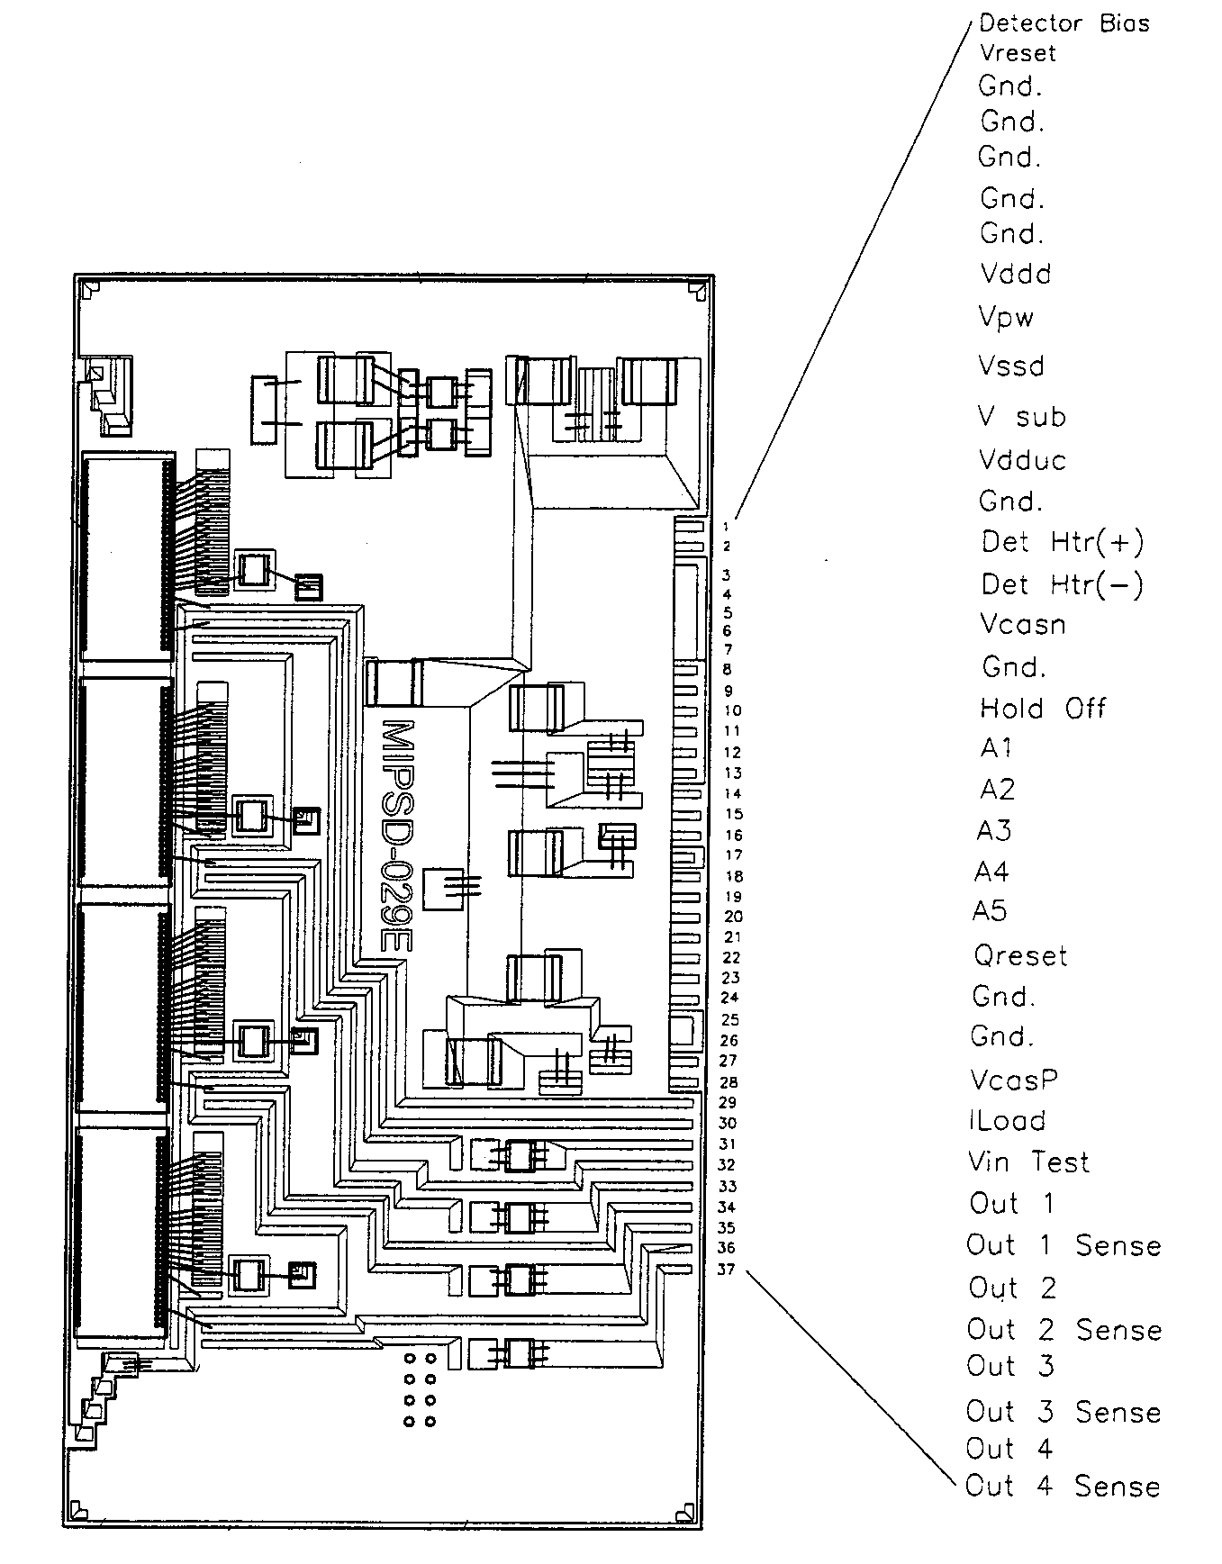
Figure 5. Ceramic multilayer board carrying four readouts for the 70 micron array.

3.4 Eliminated Failure Mechanisms

We have also eliminated a number of possible failure mechanisms:

- As shown in Figure 5, the input signals to the readout are common to three other readouts, with the necessary circuitry embedded in the multilayer ceramic board carrying the readouts. Therefore, cable failures affecting input signals are not a credible cause for the anomaly.
- An output short to chassis would not drive the output to the negative rail – the observed fault would require a short to a positive supply, which seems contrived.
• An open sense line for readout (4,4) would not produce the result because the
electronics includes a resistor on the sense line to ground to guard against this
possibility.

Figure 6. Differential amplifier receiver circuits for the two warm electronics boxes.
3.5 Failure Propagation

Reviewing these possible causes, and non-causes, there appears to be no danger of the failure propagating in any avoidable manner if we continue to operate the array, or operate it on the other combined electronics unit. Fundamentally, the likely failure mechanisms are isolated in their effects to the analog data chain associated with readout 4,4. The data line with the anomalous behavior carries only a low-power analog signal.

4. Analysis

With the possible causes of the failure isolated, we can sort through them making use of the additional information that the failure disappeared in Campaign B. This change is presumably associated with some change in circumstances.

One candidate failure mechanism is a latch condition that was reset by turning the Combined Electronics off at the end of Campaign A1 and back on for Campaign B. However, we have never seen such a condition during ground test. Such testing was conducted with the electronics close to its current operating temperature, and during Thermo/Vac, at extremes of temperature that bracketed the current on-orbit temperature. It therefore is unlikely that this explanation holds.

Failures within the array are similarly unlikely. In this case, the only change in environment is a slight cooling as the cryostat bath pumps down on orbit. However, the temperature of operation for both Campaigns A1 and B was within the range included in our groundbased testing. In addition, the temperature change between the campaigns is too small for a fault due to the launch conditions to change state.

The cryogenic cables have experienced significant changes in temperature between the two campaigns, due to the cooling of the telescope and various shields. Most of the thermometers associated with the telescope show a change of about 40K, from about 120K to about 80K. The behavior of the SIRTF cryogenic ribbon cables has been studied as described in Ball Aerospace SER S20447 – I&T (June 17, 2002). Of three flight spare cables, one showed a bad wire. The behavior was not reproducible from one cryogenic cycle to the next, but often problems appeared near temperatures of 100 to 150K. On some cycles, the conductor never failed completely down to < 100K. In tests of a second cable, known to have a bad attachment to a connector pin and removed from the flight hardware for that reason, intermittent behavior was observed during one thermal cycle but no hard failure occurred. From these tests, it does appear plausible that the behavior we have seen on readout 4,4 is associated with a bad conductor carrying its signal from the instrument to the junction box.

We therefore propose that the explanation for the anomaly on the readout 4,4 output is an intermittent failure on its output cable. Because we do not have data on the behavior of the cable at lower temperatures than achieved for Campaign B, it is not possible to project whether the problem is “fixed” as seen in that campaign, or whether the cable will open again later in the mission.

Given the uncertainty in the future state of this cable, we recommend that contingency planning continue on modification of the observing strategies with the instrument in case the readout output is lost.

