MIPS 70um FPA Anomaly Investigation
J. Heim
09/04/03

Introduction

During the first MIPS IOC Campaign, we found that one of the 32 readouts of the 70um FPA was not responding. In the ‘rail-to-rail’ test, all of the 70um pixels went to the positive rail (65535) when driven in that direction by setting the 70um bias voltage except for the 4 x 8 area known as readout 4-4. This readout read identically zero during this test, and actually, it read zero throughout the campaign.

The CE-1 combined electronics box was used during this campaign.

George Rieke wrote up a report that explains the anomaly in more detail. He also presents some possible root causes for the anomaly.

Erick Young put together a presentation for upper management regarding this anomaly.

My List of Possible Causes

- Failure in the 70um FPA itself.
    - The readout output amplifier could have failed
    - A wire bond connecting the readout to the external connector could have failed
- Failure of the interconnecting cable
    - Open circuit in the instrument cable or connector
    - Open circuit in the numerous CTA cables and connectors or in the J-box
- Failure in the Combined Electronics Box
    - Open circuit in the input connector or the motherboard connector
    - Circuit board failure (via)
    - Component attachment failure (solder joint)
    - Component failure

Discussion

In the Combined electronics box, for each of the 32 readouts of the 70um FPA there is a 5 micro-amp current source in the warm electronics which is used to bias the source follower output amplifier in the FPA. This current source is also connected to an instrumentation amplifier in the combined electronics. If the connection between the current source and the output amplifier is broken, the current source would go to its positive rail voltage (about +7V). The instrumentation amplifier and the low-pass filter that follows has a gain of –7. Thus, if the connection were broken, the output of the low-pass filter would go to the negative rail. With the filter output at the negative rail, the ADC would produce all zeros. This is exactly what we are seeing.

I think the failure would have to be an open in the line. If it were a short to the CTA chassis, I believe it would produce noisy data, but data that was on scale of the ADC.

Any of the failure mechanisms listed above would manifest itself in this way (all zeros for the readout). However, in my opinion, the most likely source of this failure would be in the FPA or in the interconnecting cables.

A failure of a solder joint or one of the components which is associated with this readout could also cause this result. This could easily be tested by turning on the instrument using CE-2.

Actions Taken Today:

- Considered location of all parts associated with this particular channel on the 70um PWA. The parts are all located in a central area of the PWB (see Figure 2 and Figure 3). Some of the parts are near the stiffener that runs across the PWA which, I believe, is attached to chassis ground. However, I don’t believe a short to chassis is likely on this PWA.
- Considered the location of the conductors in the cables. The thought here is that if the conductor was on the corner of the cable, perhaps it would be more likely to open if the connector was not fully seated.
  - The conductor is located pretty close to the middle of the connector on the PWA (P1-B15) and on the CE box connector (J-19 pin 54 of a 104 pin D connector).
  - Pin 41 on a 51 pin D connector on the J-box. This puts the conductor on the outside edge, however, not an outside corner.
  - Pin 42 on one of the 51 pin cryo cables with the Nanonics connectors. These are two row connectors.
  - Pin 12 on the instrument 51 pin MDM connector.
  - Pin 30 on the FPA 37 pin connector.

The conclusion here is that I don’t think the failure is due to the position of the conductor on one of these connectors.

- Considered an electronics failure. There are a number of components associated with this readout that would cause a failure of this nature. However, we have never had a failure in any of these components during the history of the CEs. And there are 40 identical circuits in each CE.
- Doug Kelly reviewed the telemetry from this campaign with telemetry from a recent ground test. He was looking for any changes that may indicate a failure in the electronics. The flight telemetry was very similar to the ground telemetry.

Options for testing:

- Perform a test identical to the first campaign, except use CE-2. Because we believe the cause of this anomaly is an open circuit, we feel that this would be a low risk test.
- Adjust the offset voltage on the affected half of the array to zero volts. If the voltage was just off of the ADC range, this would bring it on-scale. However, if the anomaly is due to an open in the readout output line, this won’t change anything.

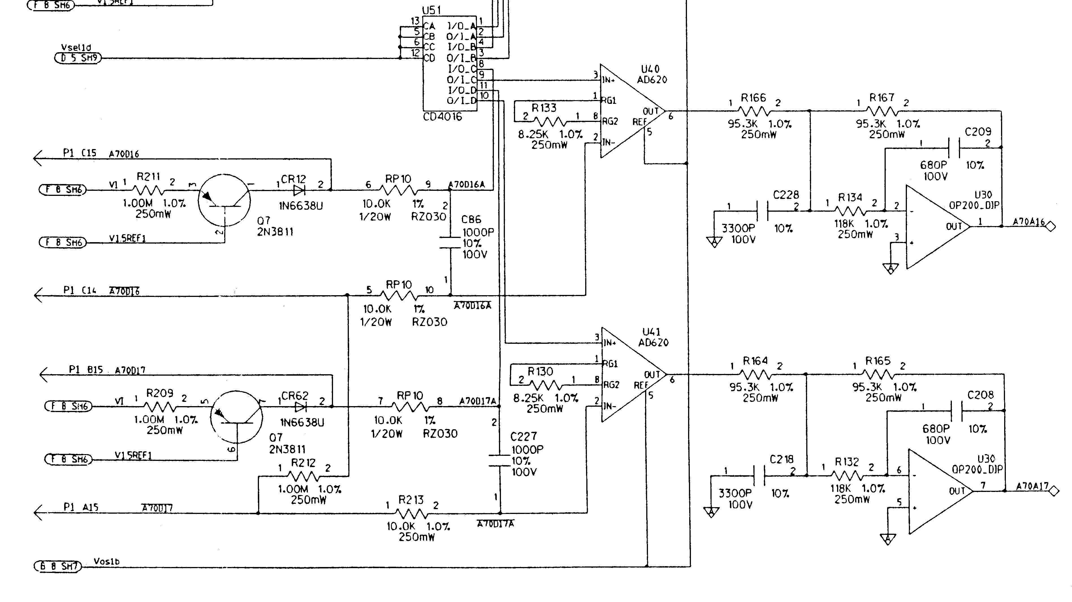
Figure 1. Schematic of 2 of the 32 identical electronics channels which are used to read out the 70 micron FPA. The channel associated with the anomalous behavior is the lower channel in this schematic. Q7 functions as the 5 micro-amp current source. U51 is the analog switch that provides isolation of the electronics in the unpowered box. U41 is the instrumentation amplifier (set to a gain of 7x). U30 and its associated passive components make up the low pass filter. The output of this circuit goes directly to a multiplexer and then to the ADC.
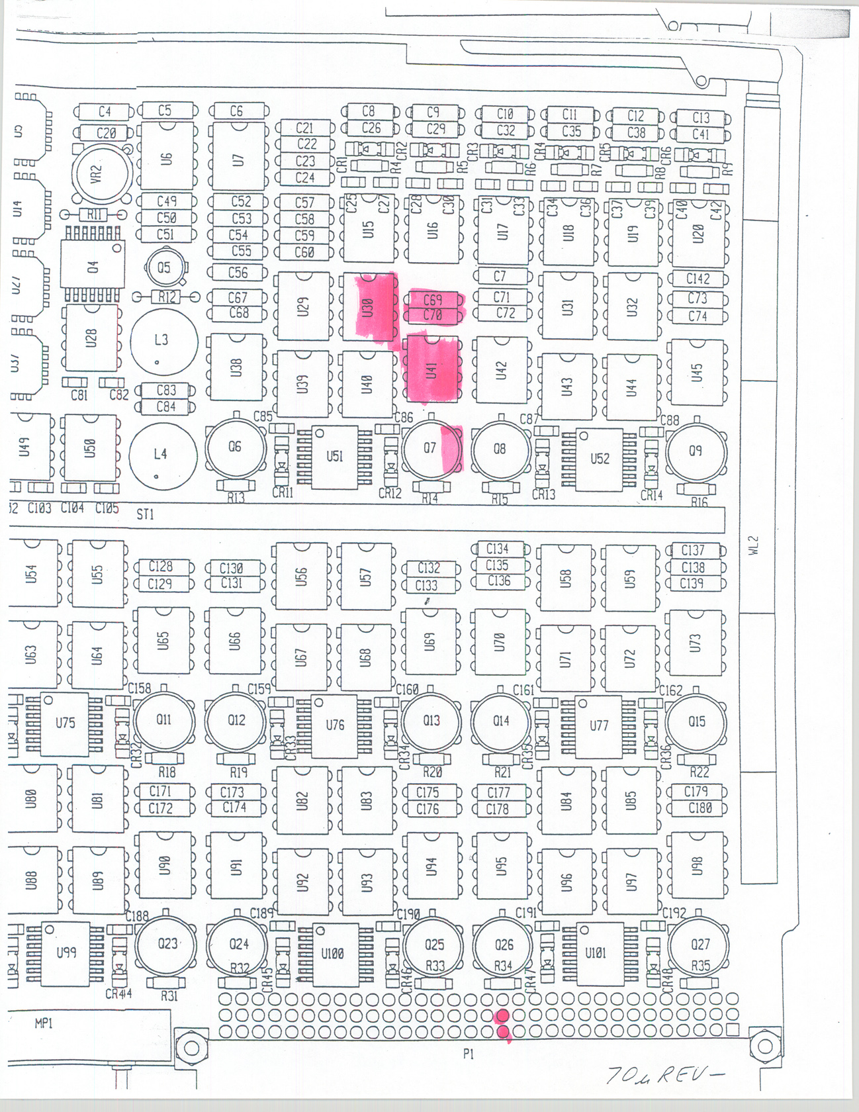
Figure 2. The location of the components on the 70 micron PWA which comprise the anomalous channel. This is a top side view of the PWA.
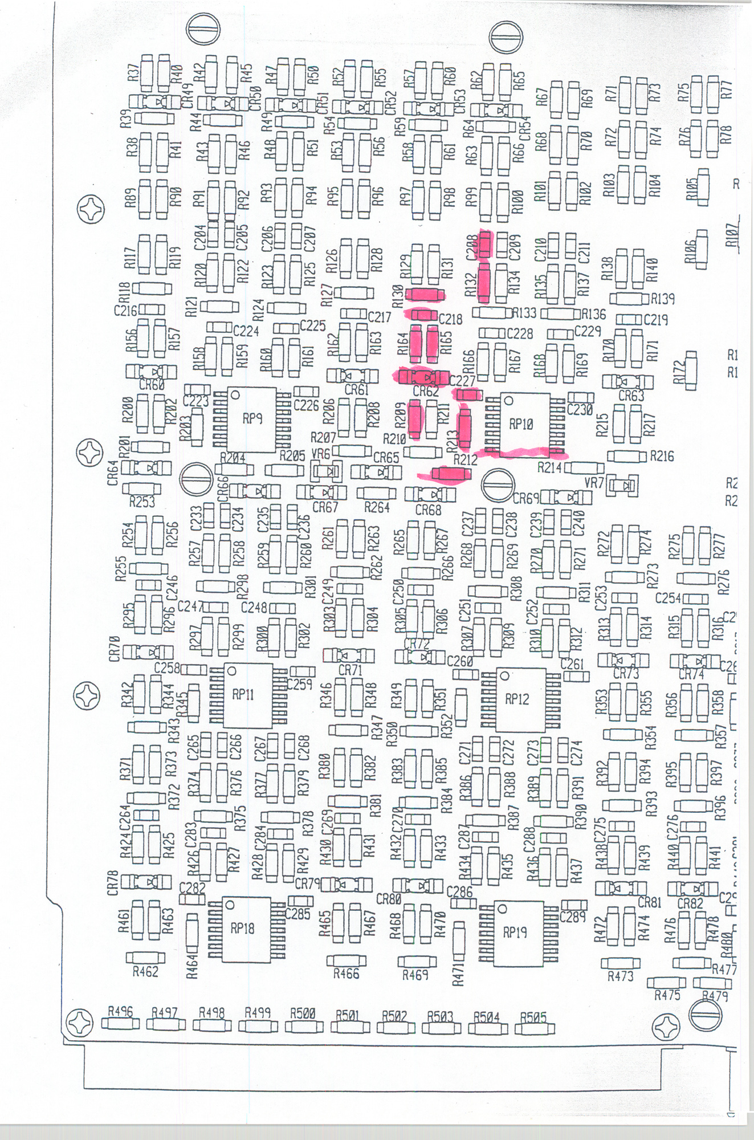
Figure 3. The location of the components on the 70 micron PWA which comprise the anomalous channel. This is a bottom side view of the PWA.

